Technical Report
Spatial Localization via Low Power Analog Circuits

Nick Iliev
Dept. ECE, School of Engineering
University of Illinois
Chicago, Illinois, USA
niliev4@uic.edu

Abstract— This paper proposes a novel application of active analog circuits for computing the Cartesian coordinates of points ( targets ) in 2D and 3D space. Two anchors ( points ) are assumed available, with known coordinates. Optical or Infrared Angle-of-Arrival , AOA, measurements from each anchor to the unknown target are assumed available with Gaussian noise added to each measurement. Linearized localization equations are derived for the case of small noise power, and two types of active analog networks are formulated for solving the resulting equations. The first type is based on simultaneous (coupled) algebraic equations and is solved via op-amps, DC voltages sources, and resistors. The second type is based on simultaneous differential equations and is solved via OTAs, op-amps, DC current sources, resistors and capacitors. Simulation results are presented which show each type of analog circuit converging to the target’s coordinates with an acceptable error. Power dissipation performance is presented as well. It is found that the coupled algebraic equations circuit has a better mapping to the original AOA equations and a better convergence to the final coordinates voltages.

Introduction
Wireless Sensor Networks ( WSNs ) are implemented with low-power sensor nodes which have a very limited power source, typically a non-rechargeable battery. The lifetime of a sensor node therefore depends on efficient operation of the node and efficient low-power modes for data collection (sensing), computation (if any), and communications with a base-station or cluster head (elected leader in a cluster of sensors). In this work we focus on low-power analog computation using sensed data for localization, which, if done in the sensor, minimizes communications and the corresponding power dissipation. The system for data sensing is optical Angle Of Arrival (AOA), including an optical source (Infrared or laser LED) and optical sensor ( photodiode and/or micro-mirror). We focus on low-power electronics for processing the AOA data and related anchor data.

PREVIOUS WORK
A large body of work exists on sensor node architectures for optical or infrared AOA localization. Most of them implement within-node computations with digital implementations with embedded processor(s) and memory, eg. Bonato 2007 (EKF/IMU optical AOA 3D localization), Frantal 2015 (Optical-Infrared 2D AOA localization). Typical reported power dissipation is from 5 mA (at 3.3V) for 2D ( Frantal, 16.5 mW) , to 0.3 A ( at 2.5 V) for 3D (Bonato, 750 mW). The proposed circuits in this work improve on this power dissipation.

PROPOSED NEW SOLUTIONS

Analog Circuits for simultaneous algebraic equations based on AOA 2D and 3D localization data

Localization in 2D via linear coupled algebraic equations

We propose to compute the sensor’s location using within-sensor (onboard) computations, based on measured AOAs and knowledge of two anchor’s coordinates. The sensor then has to transmit only it’s estimated location coordinate, instead of transmitting its individual AOA values. The computational ( data-fusion) load at the base-station (cluster head) is also reduced using this approach.
A linear active circuit for 2D localization is described below.
Localization ( find target’s x,y Cartesian coordinates) with 2 AOAs and 2 fixed anchors : for small AOA measurement errors can linearize to 2 simultaneous equations as :

a11*x + a12*y = b11
a21*x + a22 * y = b21

or

x = (b11/a11) - (a12/a11)y
y = (b21/a22) – (a21/a22)x

The coefficients in these equations are derived from two measured AOA values and two anchor’s known (x1,y1), (x2,y2) data.
These simultaneous equations, in variables x,y , can be solved by a linear active circuit made up of voltage op-amps ( diff Vin Vout) , resistors, and DC voltage sources as shown next in Fig. 1 :

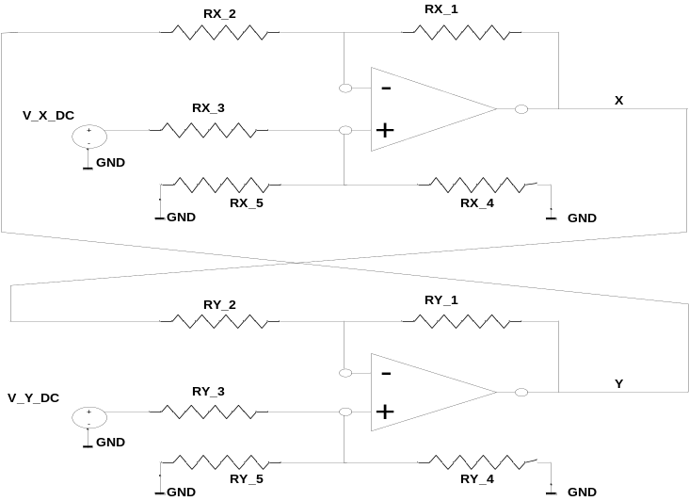

The linear circuit parameters are :

V_x_DC = (b11/a11)
V_y_DC = (b21/a22)

The negative gain, op-amp X, defined by RX_1 / RX_2 must equal a12/a11

The positive gain, op-amp X, defined by RX_4/RX_5 and RX_4/RX_3 must equal the negative gain for balanced adder/subtractor operation

The negative gain, op-amp Y, defined by RY_1 / RY_2 must equal a21/a22

The positive gain, op-amp Y, defined by RY_4/RY_5 and RY_4/RY_3 must equal the negative gain for balanced adder/subtractor operation
A balanced adder-subtractor is shown in the next Fig. 2

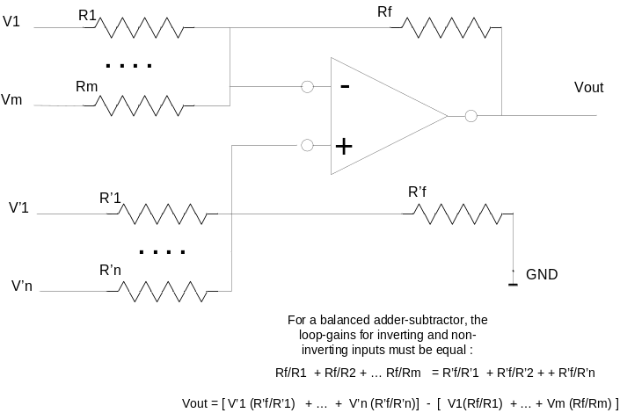

Extension to 3D Localization

The linearized system of equations is given below, from which similar expressions for x, y, and z are derived :

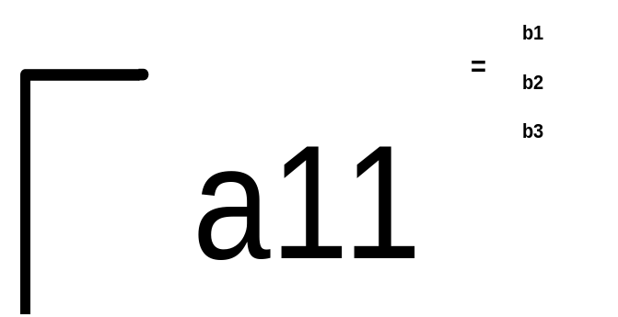

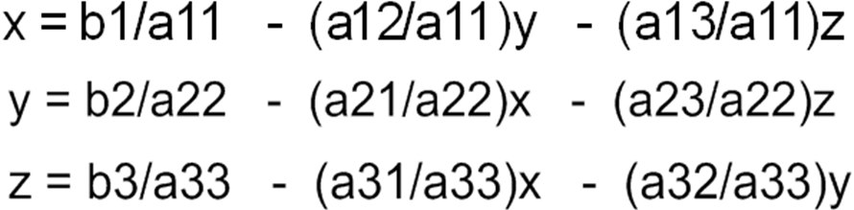

The coefficients in these equations are derived from three measured AOA values ( azimuth angles beta1, beta2, and elevation angle gamma1 ), and two anchor’s known data (x1,y1,z1) and (x2,y2,z2).
The active analog network for solving the above 3x3 system is shown below, it requires 3 op-amps , 3 DC voltage sources, and 18 resistors as shown :

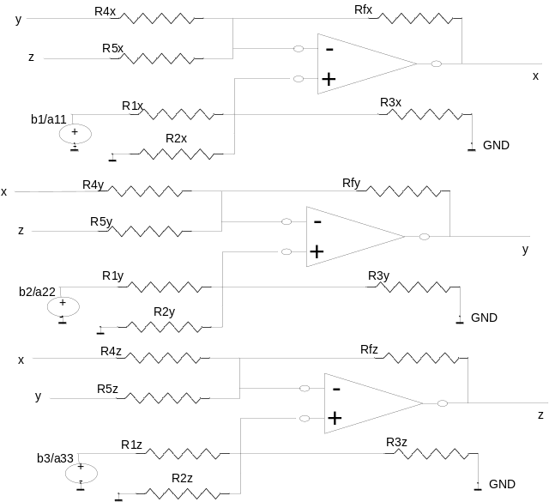

The following example is implemented : beta1 = 75.964 deg ; beta2 = -69.44 deg
gamma1 = 38.955 deg ;
Anchor1 = (2,3,4) Anchor2 = (2,23,4)

The resulting matrix equation is given below :

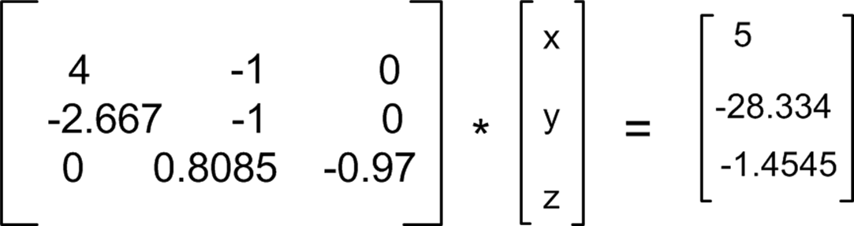

The solution is : x = 5 y = 15 z = 14.

In the following I’ll present 2D localizer circuits implementation first, followed by 3D localizer circuits implementation.

SPICE Level-54 PDK 45 nm 2D Localizer implementation, Vdd = 1V

For a low power design, a 45 nm PDK process technology was used, and the following 2D localization equations were implemented :

The true coordinates for this 2D localization case are X = 0.5 , Y = 0.5, with AOA angles beta1 = 53.123 deg, beta2 = 18.433 deg., with anchor1 (0.2, 0.1), anchor2 ( 0.2, 0.4).

The 2D system of equations is

X = 2/3 - 1/3 Y
Y = 2/3 - 1/3 X

This smaller feature process does not have a negative VSS supply, only a positive VDD = 1 V supply.

Note that in the above system of equations all coefficents are smaller than 1, ie. smaller than the 1V supply. The 2/3 value is not the actual DC source value, it is used to derive a scaled DC source value so that the gains in both positive and negative paths are equal, and the final DC source value is also less than the supply voltage. The 1/3 values are implemented with resistor ratios. Because of the DC source scaling, the final X,Y voltage values are scaled up by the same amount to compute the final coordinate. See comments in the netlists below such as “opamp for X coordinate” and comments “opamp for Y coordinate “. The details of the DC source scaling is described in these comments as well.

The impact of +1V supply on the 2D AOA equations is that negative DC sources for Vcoeff and Vcoeff2 ( equivalent to b11 and b21 equation parameters) cannot be implemented directly.

As a work-around, I have translated the 2D AOA equations to the 1st quadrant, so that only positive b11 and b21 parameters are implemented by the 45 nm circuit. Also, a positive DC term ( positive constant ) can be added to both sides of the equations to produce positive b11, b21 parameters for circuit implementation. The positive DC term is then subtracted from the final coordinate votages.

The following 45 nm op-amp and biasing network was used, based on R.J.Baker ( Reference: Baker, “CMOS Circuit Design , Layout, and Simulation”, 3rd edition, sect. 24.1 , Fig. 24.2 )

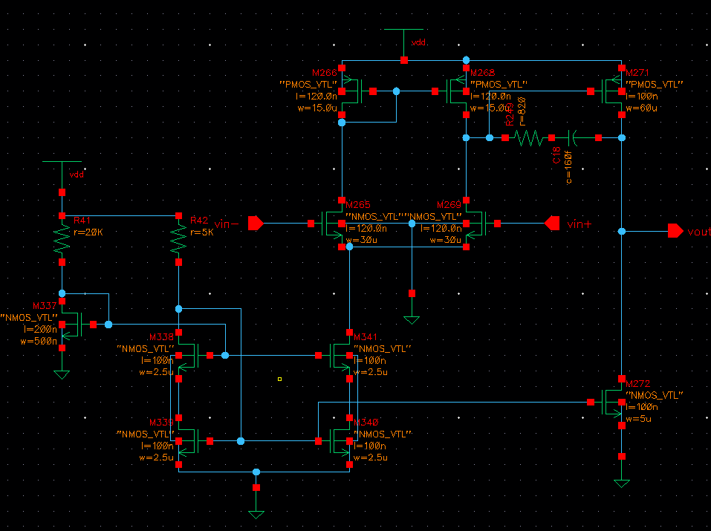

The netlist of the 2D localizer is given below, with the above opamp as instance “ .subckt opamp “

Note : the netlist is in file op_amp_2simultan_eq_2AOA_posCoeff_45nm_pwrG.sp

- The posCoeff in the name refers to positive values for b11, b21 ( Vcoeff and Vcoeff2 DC sources ) as discussed above. The values of b11,b21 must be in the 0 to 1V range. If bigger than 1, they are divided down by a scaling factor K ; K is chosen to normalize the largest (>1) DC source; the same K is applied to DC sources for all equations. For the solution, the output voltages are upscaled by the same factor K.
- The pwrG in the name refers to a power-gating circuit I’ve designed and added for evaluating power savings when VDD is gated in OFF mode.

* declare Global VDD node
.GLOBAL Vdd_top

* declare Global Virtual VDD node
.GLOBAL vdd!

.OP

.TEMP 25.0

.INCLUDE "PMOS_VTL.inc"
.INCLUDE "NMOS_VTL.inc"

* global Vdd DC source
vdd_glob Vdd_top 0 DC=1

* Power Gating Gate control DC source
* power ON = 0
* power OFF = 1
pwr_c pwrG_ctrl 0 DC=0

* PMOS Power Gating Transistor
* D G S B
* m444 vdd! pwrG_ctrl Vdd_top Vdd_top PMOS_VTL L=100e-9 W=60e-6 AD=6.3e-12 AS=6.3e-12 PD=60.21e-6 PS=60.21e-6 M=1
m444 vdd! pwrG_ctrl Vdd_top Vdd_top PMOS_VTL L=120e-9 W=15e-6 AD=1.575e-12 AS=1.575e-12 PD=15.21e-6 PS=15.21e-6 M=1

*- OpAmp
** Cell name: opamp
** View name: schematic

* positive in _net0 negative in _net1

.subckt opamp _net0 _net1 vout
m272 vout net7 0 0 NMOS_VTL L=100e-9 W=5e-6 AD=525e-15 AS=525e-15 PD=5.21e-6 PS=5.21e-6 M=1
m269 net20 _net0 net14 0 NMOS_VTL L=120e-9 W=30e-6 AD=3.15e-12 AS=3.15e-12 PD=30.21e-6 PS=30.21e-6 M=1
m265 net15 _net1 net14 0 NMOS_VTL L=120e-9 W=30e-6 AD=3.15e-12 AS=3.15e-12 PD=30.21e-6 PS=30.21e-6 M=1
m340 net29 net7 0 0 NMOS_VTL L=100e-9 W=2.5e-6 AD=262.5e-15 AS=262.5e-15 PD=2.71e-6 PS=2.71e-6 M=1
m341 net14 net4 net29 0 NMOS_VTL L=100e-9 W=2.5e-6 AD=262.5e-15 AS=262.5e-15 PD=2.71e-6 PS=2.71e-6 M=1
m338 net7 net4 net30 0 NMOS_VTL L=100e-9 W=2.5e-6 AD=262.5e-15 AS=262.5e-15 PD=2.71e-6 PS=2.71e-6 M=1
m339 net30 net7 0 0 NMOS_VTL L=100e-9 W=2.5e-6 AD=262.5e-15 AS=262.5e-15 PD=2.71e-6 PS=2.71e-6 M=1
m337 net4 net4 0 0 NMOS_VTL L=200e-9 W=500e-9 AD=52.5e-15 AS=52.5e-15 PD=710e-9 PS=710e-9 M=1
m271 vout net20 vdd! vdd! PMOS_VTL L=100e-9 W=60e-6 AD=6.3e-12 AS=6.3e-12 PD=60.21e-6 PS=60.21e-6 M=1
m268 net20 net15 vdd! vdd! PMOS_VTL L=120e-9 W=15e-6 AD=1.575e-12 AS=1.575e-12 PD=15.21e-6 PS=15.21e-6 M=1
m266 net15 net15 vdd! vdd! PMOS_VTL L=120e-9 W=15e-6 AD=1.575e-12 AS=1.575e-12 PD=15.21e-6 PS=15.21e-6 M=1

r249 net20 net32 820
r42 vdd! net7 5e3
r41 vdd! net4 20e3
c18 net32 vout 160e-15
.ends opamp
** End of subcircuit definition.

* opamp for X coordinate
* begin

xamp1 inp inm out opamp

rf inm out 100k
r1 out2 inm 300k

rpf inp 0 100k

* original (2/3)*6 = 4, ( *6 to match gain of negative path) then divide down by 4.4
* for 1V supply , 4/4.4 = 0.909V
Vcoeff vrp1 0 dc 0.909

*VDCfromop vfrom 0 dc 2
*xtest vrp1 out settling_test v0=0 v1=2 interval=10u

rp1 vrp1 inp 600k

rpy inp 0 600k
* end

* opamp for Y coordinate
* begin

* gain (inverting terminal) is -0.5

xamp2 inp2 inm2 out2 opamp
rf2 inm2 out2 100k
r12 out inm2 300k

* gain (noninv terminal) is 0.25 + 0.25

* 1/3 + 1/3
rpf2 inp2 0 100k

* (2/3)*6 = 4 ( *6 to match gain of negative path), then scaled down by 4.4 = 0.909V for < 1V supply

Vcoeff2 vrp2 0 dc 0.909

rp12 vrp2 inp2 600k

rpy2 inp2 0 600k
* end

.PROBE V(out)
.PROBE V(out2)

.tran 10p 6u 0.0 0.01u

.measure tran curr_vdd1 avg I(vdd_glob) FROM=1ns TO=6u
.measure tran pwr_vdd1 PARAM='curr_vdd1*1.0'

.measure tran curr_vco1 avg I(Vcoeff) FROM=1ns TO=6u
.measure tran pwr_vco1 PARAM='curr_vco1*0.0832'

.measure tran curr_vco2 avg I(Vcoeff2) FROM=1ns TO=6u
.measure tran pwr_vco2 PARAM='curr_vco2*0.8333'

.measure tran total_pwr PARAM='pwr_vdd1+pwr_vco1+pwr_vco2'

***--------------------------
.OPTION INGOLD=2 ARTIST=2 PSF=2 PROBE=0 GMMIN=1e-15 METHOD=GEAR
.OPTION POST
*.TEMP 30
.OPTIONS SCALE = 1.00
.SAVE

.end

The true coordinates for this 2D localization case are X = 0.5 , Y = 0.5, with AOA angles beta1 = 53.123 dev, beta2 = 18.433 deg.

The 2D system of equations is

X = 2/3 - 1/3 Y
Y = 2/3 - 1/3 X

Simulation results for V(out) = X coordinate, and V(out2) = Y coordinate are shown below : up-scaling b 4.4 is done for each voltage value, to obtain the final coordinate estimate :

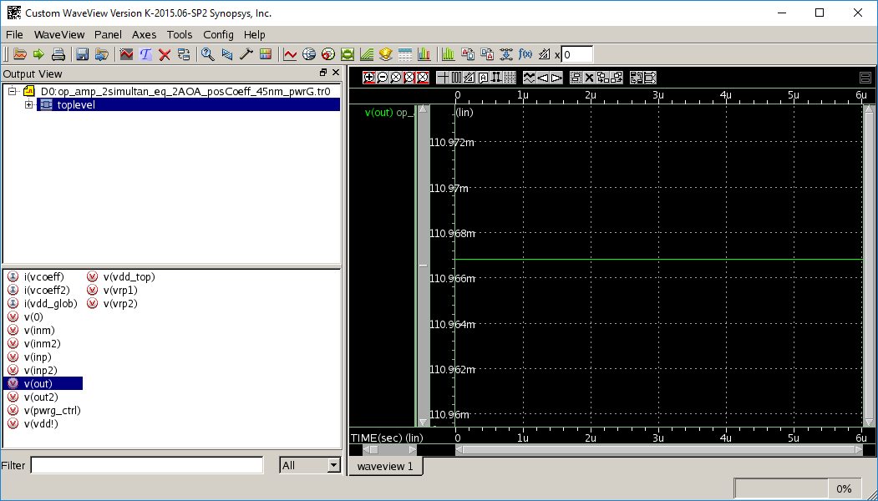

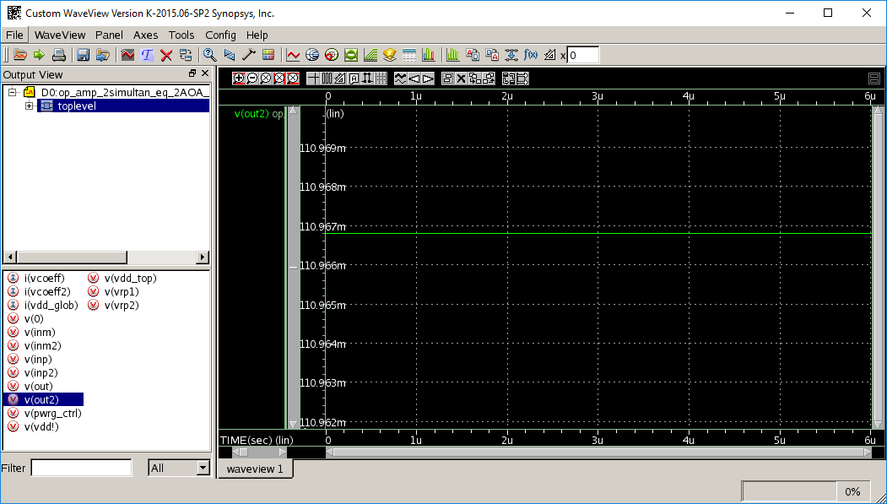

Both V(out) and V(out2) are about 110.967 mV, and when scaled up by 4.4 ( since the circuit’s DC sources were scaled down by 4.4 ), we get 110.967 mV * 4.4 = 488.25 e-3;

This is approximately 0.5 ( 500 e-3 ) for X and Y coordinates which is the true solution.

Note : the above simulation results are in Power-ON mode,

ie. When the power-gating PMOS is ON , by setting the pwr_c DC source to 0 :

* Power Gating Gate control DC source
* power ON = 0
* power OFF = 1
pwr_c pwrG_ctrl 0 DC=0

2D Localizer PDK 45nm – Power Dissipation, Vdd = 1V

The above 45 nm 2D Localizer circuit was simulated in the Power ON mode, with the above pwr_c DC source = 0 ;
The pwr_c is driven to 0V :
* Power Gating Gate control DC source
* power ON = 0
* power OFF = 1
pwr_c pwrG_ctrl 0 DC=0

The power dissipation was estimated at 782.9 uW , from file
Loc_2D_PDK45nm_ON_State.mt0 shown below :

$DATA1 SOURCE='HSPICE' VERSION='K-2015.06-SP2 linux64' PARAM_COUNT=0
.TITLE ' '
curr_vdd1 pwr_vdd1 curr_vco1 pwr_vco1
curr_vco2 pwr_vco2 total_pwr temper
alter#
-7.817e-04 -7.817e-04 -1.325e-06 -1.103e-07
-1.325e-06 -1.104e-06 -7.829e-04 2.500e+01
1

The above 45 nm 2D Localizer circuit was simulated in the Power OFF mode, with the above pwr_c DC source = 1 ;
The pwr_c is driven to 1V :
* Power Gating Gate control DC source
* power ON = 0
* power OFF = 1
pwr_c pwrG_ctrl 0 DC=1

The power dissipation in OFF state was estimated at 1.243 uW , from file Loc_2D_PDK45nm_OFF_State.mt0 shown below :

$DATA1 SOURCE='HSPICE' VERSION='K-2015.06-SP2 linux64' PARAM_COUNT=0
.TITLE ' '
curr_vdd1 pwr_vdd1 curr_vco1 pwr_vco1
curr_vco2 pwr_vco2 total_pwr temper
alter#
-2.849e-08 -2.849e-08 -1.326e-06 -1.103e-07
-1.326e-06 -1.105e-06 -1.243e-06 2.500e+01
1

In the OFF state, the V(out) and V(out2) nodes dischared to about 14.53 mV.

Complete discharge to 0mV is not possible due to each opamp’s capacitor in the RC compensation path to the output node.

Reducing VDD Supply for Lower Power with Vdd = 0.6V

To further reduce power dissipation in ON mode,
a Vdd is chosen based on ( (2/3)*6) / 7.067 = 0.566 V ( largest DC source was (2/3)*6/4.4 = 0.909V). Since 0.6 > 0.566, Vdd = 0.6 V was used as the supply since it is also greater than the max common mode voltage. All Vcoeff DC sources were also recomputed as follows :

Vcoeff = ((2/3) *6) / 7.067 = 0.566 V
Vcoeff2 = ((2/3) *6) / 7.067 = 0.5667V

The corresponding output node voltages are shown in the following simulations, converging to the expected true values. Up-scaling by 7.067 is applied to each voltage value, to obtain the final coordinate.

X = V(out) = 67.713 mV * 7.067 = 478.5 e-3 approx. 0.5 ( 0.5 true)

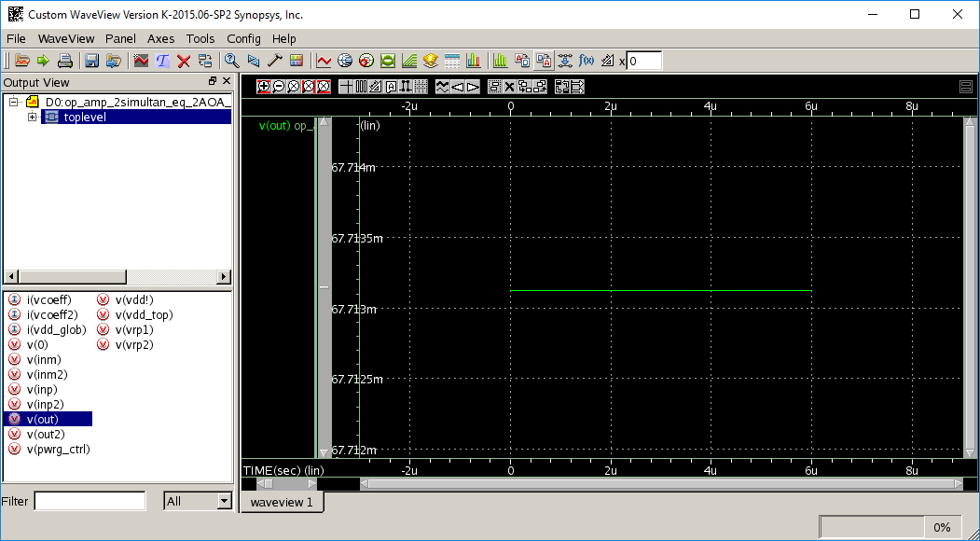

Y = V(out2) = 67.713 mV * 7.067 = 478.5 e-3 approx. 0.5 (0.5 true)

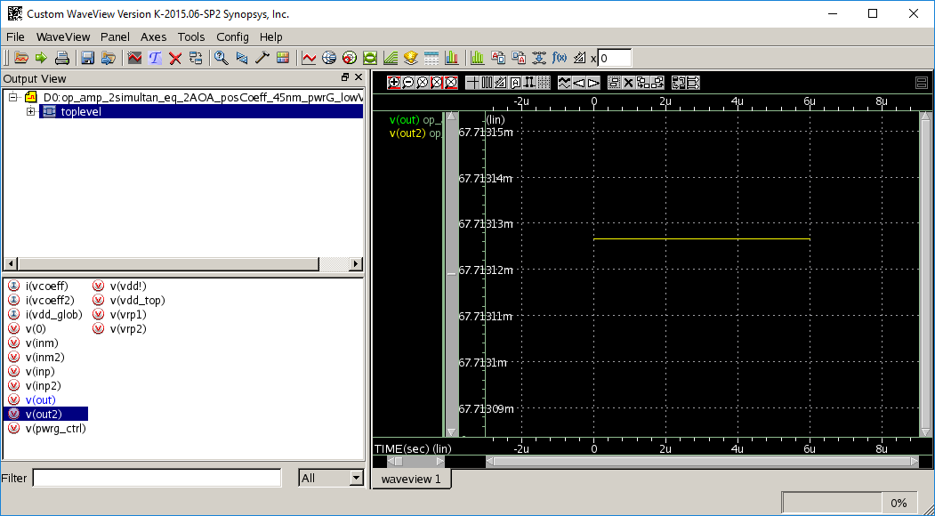

Power dissipation in the ON state is 173 uW , from file loc_2D_PDK45nm_ON_state_Vdd_0p6.mt0 ;
$DATA1 SOURCE='HSPICE' VERSION='K-2015.06-SP2 linux64' PARAM_COUNT=0
.TITLE ' '
curr_vdd1 pwr_vdd1 curr_vco1 pwr_vco1
curr_vco2 pwr_vco2 total_pwr temper
alter#
-2.867e-04 -1.720e-04 -8.254e-07 -4.672e-07
-8.254e-07 -4.672e-07 -1.730e-04 2.500e+01
1

Power dissipation in the OFF state is 0.934 uW ,
from file loc_2D_PDK45nm_OFF_state_Vdd_0p6.mt0 :
$DATA1 SOURCE='HSPICE' VERSION='K-2015.06-SP2 linux64' PARAM_COUNT=0
.TITLE ' '
curr_vdd1 pwr_vdd1 curr_vco1 pwr_vco1
curr_vco2 pwr_vco2 total_pwr temper
alter#
6.301e-10 3.781e-10 -8.254e-07 -4.672e-07
-8.254e-07 -4.672e-07 -9.340e-07 2.500e+01
1

In conclusion, considerable ON-state power savings were achieved ( 4.52 times reduction 782.9/173 ) by reducing the Vdd supply voltage from 1V to 0.6V ; OFF-state power savings were also achieved ( 1.33 times reduction 1.243/0.934 ) by reducing Vdd to 0.6V.
It is possible to improve even further on this, by redesigning the bias network sinking tail current at the drain of transistor M341 : resistors R41 and R42 can be resized for a lower bias current. However due to time limitations of this project, changes to the bias network were not attempted.

3D Localizer – SPICE Level-54 PDK 45nm implementation, Vdd = 1V

The true coordinates for this 3D localization case are X = 5 , Y = 15 , Z = 14 with AOA angles beta1 = 75.96 deg, beta2 = -69.44 deg and gamma1 = 38.95 dev. Anchor 1 is at (2,3,4), and Anchor2 is at (2,23,4).

The 2D system of equations is

X = 1.25 + 0.25 * Y
Y = 28.334 - 2.667* X
Z = 1.4995 + 0.8335 * Y

The DC sources are scaled down, similar to the 2D case.
The largest value is b2 = 28.334, so I divide down all sides by 30 so that all voltages are below 1V ( VDD supply ).

The DC sources are :

Vcoeff = (b1/30)*8 = (1.25/30)*8 = 0.333V
The multiply by 8 is required to make the net negative gain equal to the net positive gain for X opamp’s positive and negative paths.

Vcoeff2 = b2/30 = 28.334/30 = 0.944V
No additional scaling is needed here, since the Y opamp’s positive and negative paths are equal.

Vcoeff3 = b3/30 = (1.4995/30)*2.3995 = 0.12 V
The multiply by 2.3995 is required to make the net negative gain equal to the net positive gain for the Z opamp’s positive and negative paths.

The netlist of the 3D localizer is given below, with the above opamp as instance “ .subckt opamp “

Note : the netlist is in file op_amp_3simultan_eq_2AOA_posCoeff_45nm_pwrG.sp

- The posCoeff in the name refers to positive values for b1, b2, b3 ( Vcoeff , Vcoeff2 , Vcoeff3 DC sources ) as discussed above. Similarly, the largest ( < 1 ) DC source is divided down by K and K is applied to the DC sources of all equations. The output voltages are then scaled up by K to arrive at the final solution.

- The pwrG in the name refers to a power-gating circuit I’ve designed and added for evaluating power savings when VDD is gated in OFF mode.

* opamp for X coordinate which is voltage out*30 , as explained above
* begin
xamp1 inp inm out opamp
rf inm out 100k
r1 out2 inm 400k
rpf inp 0 100k

Vcoeff vrp1 0 dc 0.333

rp1 vrp1 inp 800k
rpy inp 0 800k
* end

* opamp for Y coordinate which is voltage out2 * 30
* begin
xamp2 inp2 inm2 out2 opamp
rf2 inm2 out2 100k
r12 out inm2 37.495k

* gain (noninv terminal) is 1 + 1.667 = 2.667
rpf2 inp2 0 100k

Vcoeff2 vrp2 0 dc 0.944

rp12 vrp2 inp2 100k
rpy2 inp2 0 59.988k
* end

* opamp for Z coordinate which is voltage out3 * 30
* begin
xamp3 inp3 inm3 out3 opamp

rf3 inm3 out3 100k
r13 out2 inm3 119.976k

rpf3 inp3 0 100k

Vcoeff3 vrp3 0 dc 0.12

rp13 vrp3 inp3 239.952k
rpy3 inp3 0 239.952k
* end

.PROBE V(out)
.PROBE V(out2)
.PROBE V(out3)

.tran 10p 6u 0.0 0.01u

.measure tran curr_vdd1 avg I(vdd_glob) FROM=1ns TO=6u
.measure tran pwr_vdd1 PARAM='curr_vdd1*1.0'

.measure tran curr_vco1 avg I(Vcoeff) FROM=1ns TO=6u
.measure tran pwr_vco1 PARAM='curr_vco1*0.333'

.measure tran curr_vco2 avg I(Vcoeff2) FROM=1ns TO=6u
.measure tran pwr_vco2 PARAM='curr_vco2*0.944'

.measure tran curr_vco3 avg I(Vcoeff3) FROM=1ns TO=6u
.measure tran pwr_vco3 PARAM='curr_vco3*0.12'

.measure tran total_pwr PARAM='pwr_vdd1+pwr_vco1+pwr_vco2+pwr_vco3'

Simulation and convergence of X coordinate V(out) to approx. 161.366 mV is shown in the plot below. Up-scaling by 30 is applied to each voltage value to obtain the final coordinate.
Scaling up by 30 : 161.366mV * 30 = 4.84 ( true is 5 )

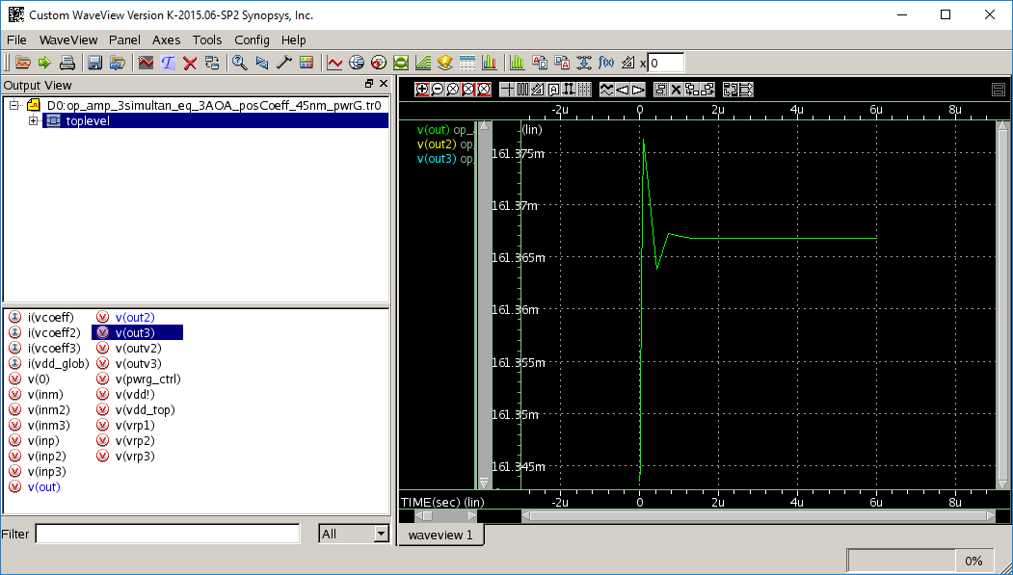

Simulation and convergence of Y coordinate V(out2) to approx. 510.366 mV is shown in the plot below.
Scaling up by 30 : 510.366mV * 30 = 15.31 ( true is 15 )

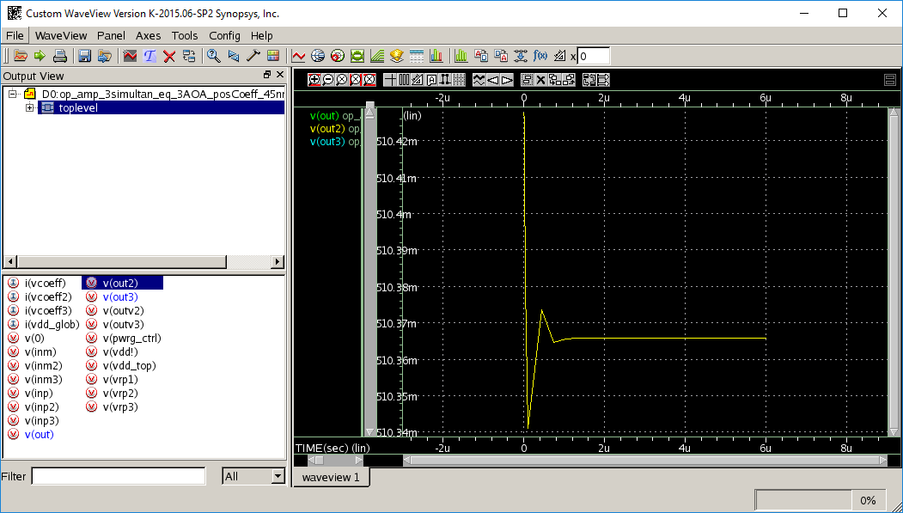

Simulation and convergence of Z coordinate V(out3) to approx. 460.965 mV is shown in the plot below.
Scaling up by 30 : 460.965mV * 30 = 13.83 ( true is 14 )

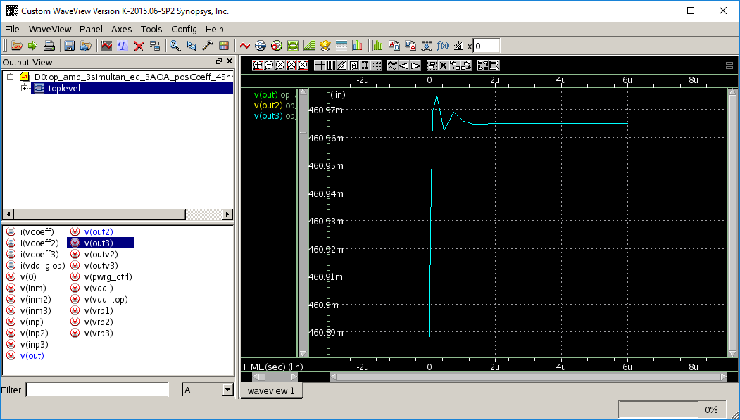

3D Localizer – SPICE Level-54 PDK 45nm Power Dissipation, Vdd = 1V

In the ON state, the power dissipation was estimated at 1.277 mW , from file
Loc_3D_PDK45nm_ON_State.mt0 shown below :

$DATA1 SOURCE='HSPICE' VERSION='K-2015.06-SP2 linux64' PARAM_COUNT=0
.TITLE ' '
curr_vdd1 pwr_vdd1 curr_vco1 pwr_vco1
curr_vco2 pwr_vco2 curr_vco3 pwr_vco3
total_pwr temper alter#
-1.271e-03 -1.271e-03 -3.744e-07 -1.247e-07
-6.866e-06 -6.481e-06 -3.859e-07 -4.631e-08
-1.277e-03 2.500e+01 1

In the OFF state, the power dissipation was estimated at 6.681uW , from file Loc_3D_PDK45nm_OFF_State.mt0 shown below :
$DATA1 SOURCE='HSPICE' VERSION='K-2015.06-SP2 linux64' PARAM_COUNT=0
.TITLE ' '
curr_vdd1 pwr_vdd1 curr_vco1 pwr_vco1
curr_vco2 pwr_vco2 curr_vco3 pwr_vco3
total_pwr temper alter#
-2.858e-08 -2.858e-08 -3.746e-07 -1.248e-07
-6.866e-06 -6.481e-06 -3.864e-07 -4.637e-08
-6.681e-06 2.500e+01 1

In the OFF state, the V(out) output node discharged to 2.767 mV, V(out2) output node discharged to 3.405 mV, and V(out3) output node discharged to 543.23 uV.

Compete discharge to 0mV is not possible due to each opamp’s capacitor in the RC compensation path to the output node.

Reducing VDD Supply for Lower Power with Vdd = 0.6V

To further reduce power dissipation in ON mode,
a Vdd is chosen based on 28.334 / 50 = 0.566 V ( largest DC source was 28.334). Since 0.6 > 0.566, Vdd = 0.6 V was chosen, since it is also greater than the max common mode voltage. All Vcoeff DC sources were also recomputed as follows :

Vcoeff = (1.25*8)/50 = 0.2V ( *8 required for +/- path equalization)
Vcoeff2 = 28.334/50 = 0.5667V ( no +/- path equalization needed)
Vcoeff3 = (1.4995*2.3995)/50 = 0.072V ( *2 required for +/- path equalization)

The corresponding output node voltages are shown in the following simulations, converging to the expected true values. Up-scaling by 50 of each voltage value is applied to estimate the final coordinate.

X = V(out) = 94.532 mV * 50 = 4.73 approx. 5 (true)

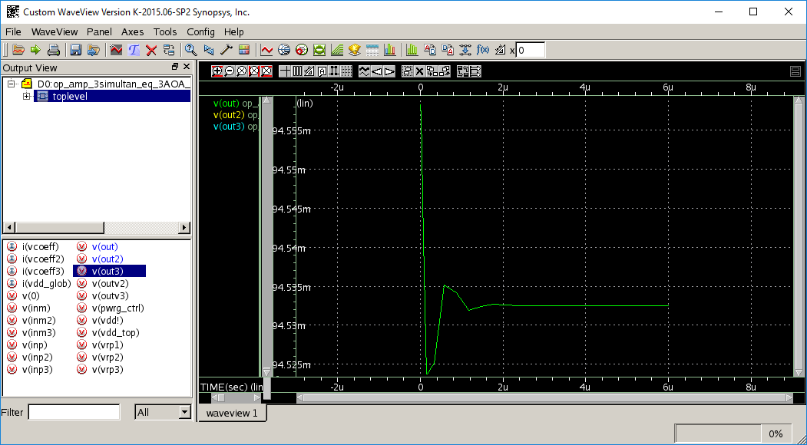

Y = V(out2) = 309.014 mV * 50 = 15.45 approx. 15 (true )

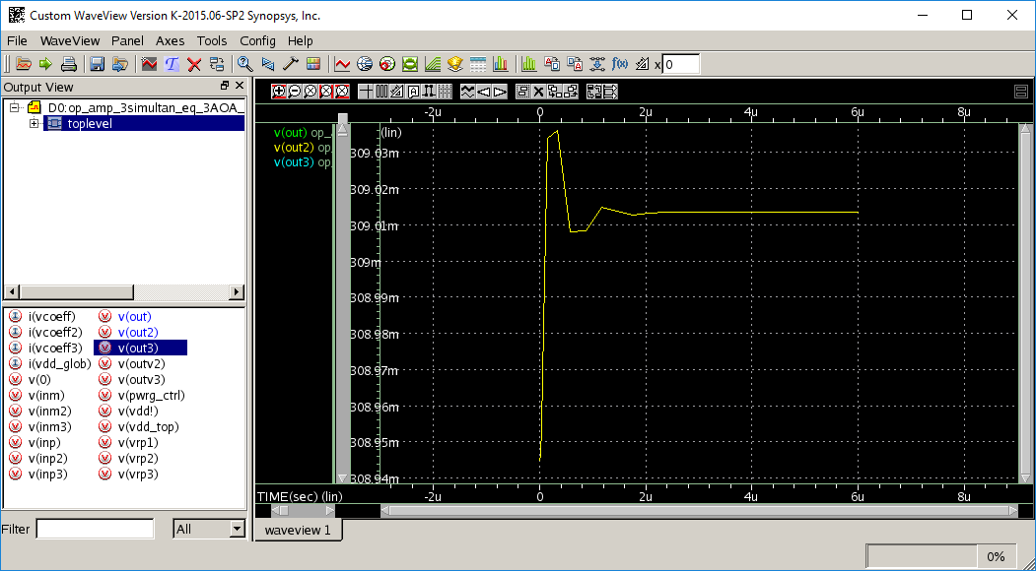

Z = V(out3) = 274.6874 mV * 50 = 13.7 approx. 14 (true)

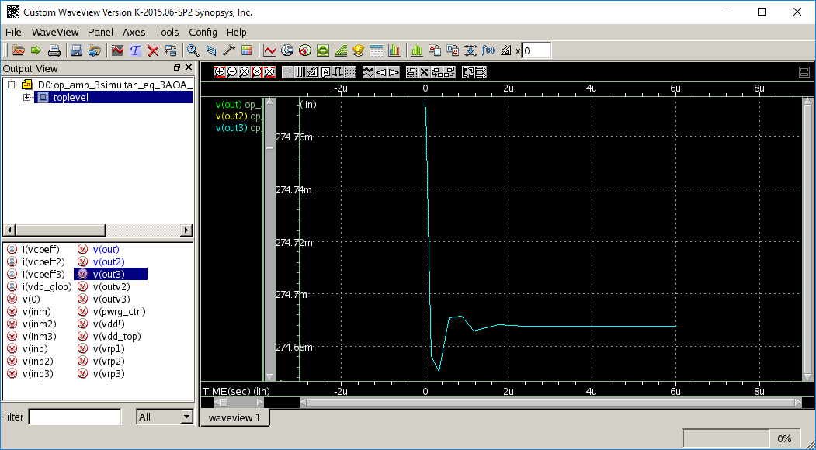

The new power dissipation in the ON state is 463.7 uW, as reported in file loc_3D_PDK45nm_ON_state_Vdd_0p6.mt0
:
$DATA1 SOURCE='HSPICE' VERSION='K-2015.06-SP2 linux64' PARAM_COUNT=0
.TITLE ' '
curr_vdd1 pwr_vdd1 curr_vco1 pwr_vco1
curr_vco2 pwr_vco2 curr_vco3 pwr_vco3
total_pwr temper alter#
-4.597e-04 -4.597e-04 -2.250e-07 -7.492e-08
-4.122e-06 -3.891e-06 -2.318e-07 -2.782e-08
-4.637e-04 2.500e+01 1

In the OFF state, power dissipation is at 3.993 uW, as shown in the OFF_state_Vdd_0p6 .mt0 file below

$DATA1 SOURCE='HSPICE' VERSION='K-2015.06-SP2 linux64' PARAM_COUNT=0
.TITLE ' '
curr_vdd1 pwr_vdd1 curr_vco1 pwr_vco1
curr_vco2 pwr_vco2 curr_vco3 pwr_vco3
total_pwr temper alter#
6.301e-10 6.301e-10 -2.250e-07 -7.493e-08
-4.122e-06 -3.891e-06 -2.319e-07 -2.782e-08
-3.993e-06 2.500e+01 1

In conclusion, considerable ON-state power savings were achieved ( 2.75 times reduction, 1277/463.7 ) by reducing the Vdd supply voltage from 1V to 0.6V ; OFF-state power savings were also achieved ( 1.67 times reduction, 6.681/3.993 ) by reducing Vdd to 0.6V.
It is possible to improve even further on this, by redesigning the bias network sinking tail current at the drain of transistor M341 : resistors R41 and R42 can be resized for a lower bias current. However due to time limitations of this project, changes to the bias network were not attempted.

Analog Circuits for simultaneous differential equations based on AOA 2D and 3D localization data

A different circuit solution to the same localization problem can be obtained by formulating the localization problem as a system of coupled differential equations as shown below :
Identify applicable sponsor/s here. If no sponsors, delete this text box (sponsors).

Linear Coupled Differential equation circuit for 2D localization

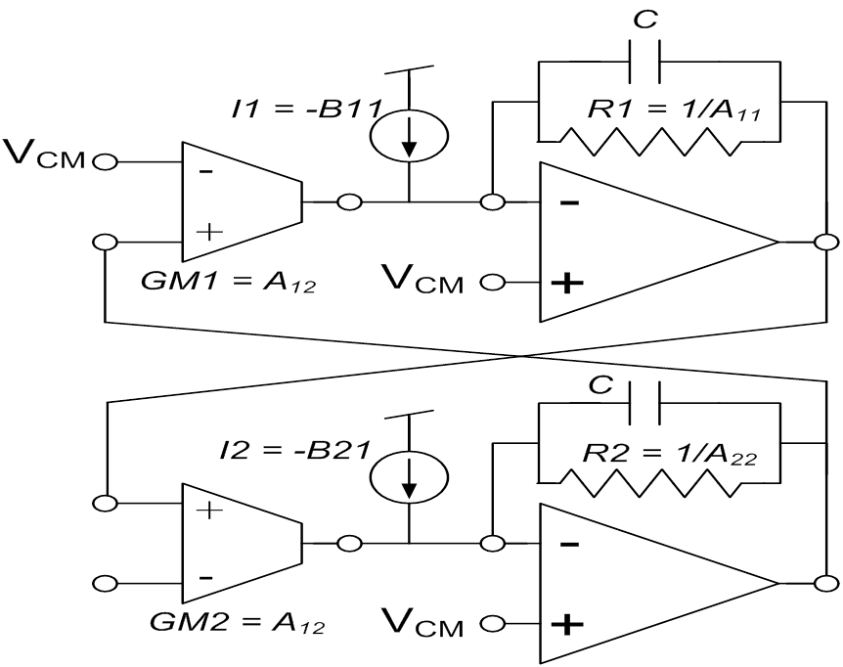

Possible issues : At 45nm and low ( +1V) supplies a small signal swing results in GM1…B11, R1, and other circuit params which can’t map to the 2D AOA equations

OTA Verilog-A completed – unit tested in HSpice sims
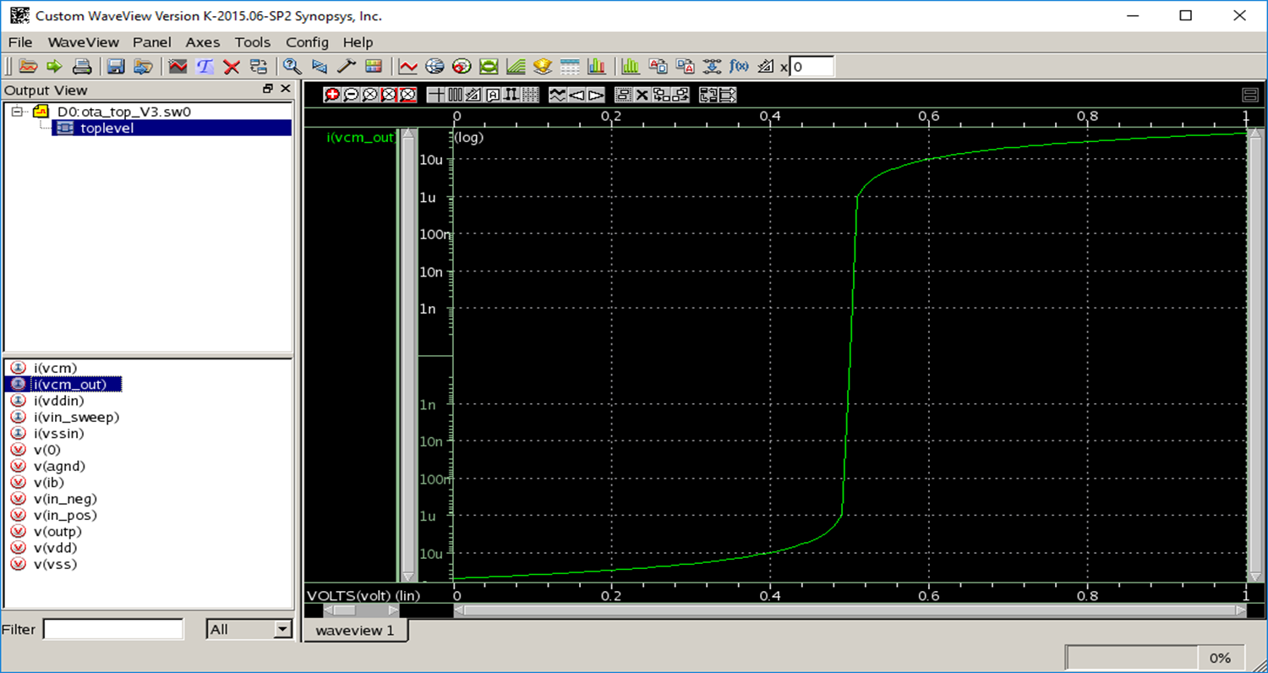

The above plot is example simulation output : OTA output current I(Vcm_out) vs input voltage difference V Hspice simulation : Vcm (common mode V) = 0.5V

Opamp Verilog-A completed – unit tested in HSpice sims
Unit Gain configuration, output voltage V(out) follows input voltage V(inp) on positive 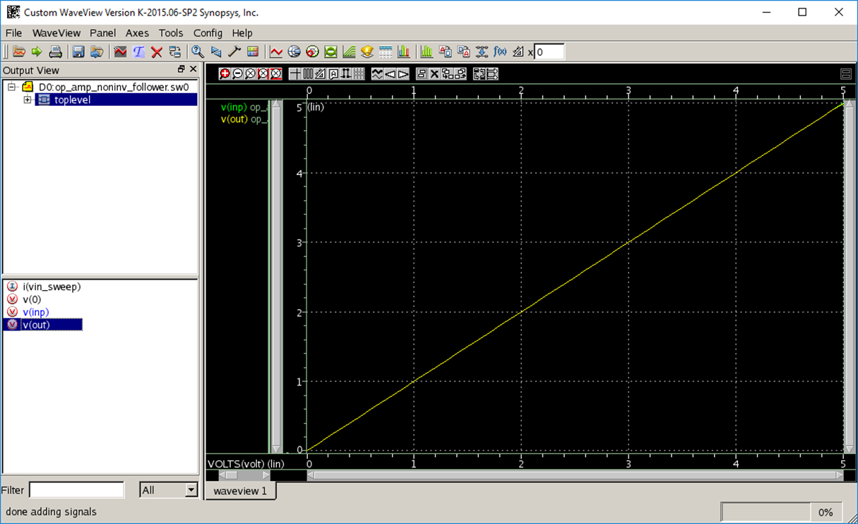ositive terminal

DE_Solver in Verilog-A complete 2D circuit
A complete Verilog-A implementation of the above 2 OTA, 2 op-amp schematic was done, file ota_top_v4.sp shown below :

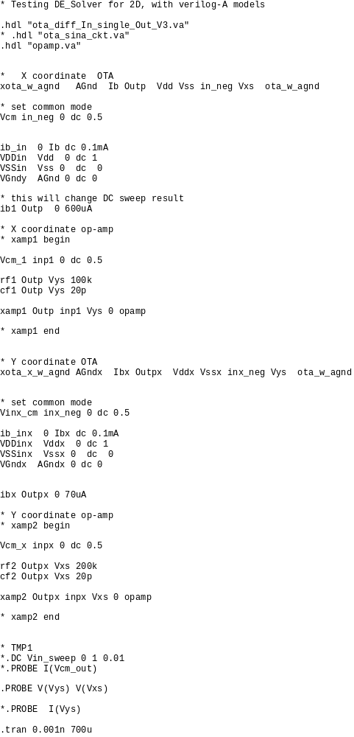

Currently, output voltages, Vxs, Vys , for X and Y coordinates respectively, don’t converge to the expected values. More debug of this circuit is required.

DE Solver in HSpice complete 2 D circuit

Next, an HSpice implementation was completed, re-using the op-amp ( PDK 45 nm ) from the algebraic system above;
and re-using OTA and biasing network ( also in PDK 45nm ) from Sina’s RNG project ; the OTA is shown below :

and its biasing netowk is shown below :

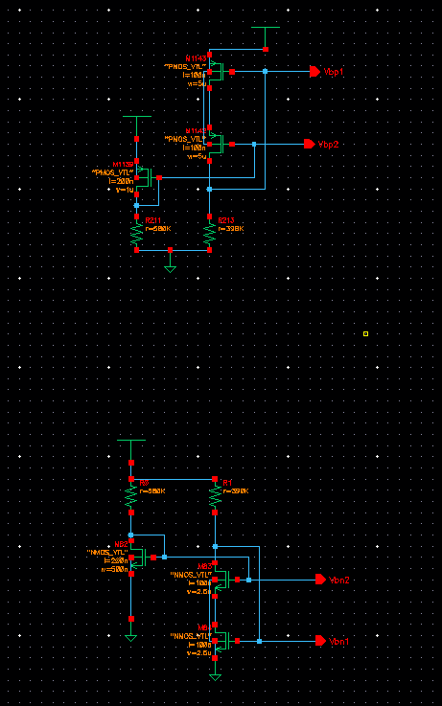

This circuit did converge to stable Vxs, Vys voltages values ( 610.42 mV , 561.9 mV ) for the following circuit parameters
R1 = 20 KOhm
R2 = 30 KOhm
C = 100 fF:
iB1 = 6 uA
iB2 = 2.9 uA
Vcm = 0.5 V
Gm1 = Gm2 = 7.4 uSiemens
However, there’s no mapping to actual 2D AOA equation coefficients which can produce these final voltage values of Vxs, Vys. More work is required to debug this mapping issue. A different scaling factor(s) should be found to allow for a working mapping. Also, the OTA’s GM1 linear range can be increased, around Vcm , by re-designing the OTA.

Alternatively, one can use Si-Ge TFET OTAs and opamps for much larger linear range of GM1 ( as big as -40 mV and 40 mV across Vcm ) thus allowing larger range of corresponding AOA equation coefficients

- Discussion and future work

We’re presented two analog circuit designs for on-chip sensor localization, using measured AOA values with two or more known anchor’s coordinates.
The first op-amp based circuit solves 2D and 3D simultaneous algebraic equations with circuit output voltages converging to values which can be up-scaled to the correct final coordinates. AOA-based equation coefficients are used to derive resistor ratios and DC source values. In practical realization, for 2D, the 360 degree space can be divided into 12 regions, each region with aperture of 30 degrees, as in the Frantal 2015 implmentation. The 12 30-degree regions are shown below :
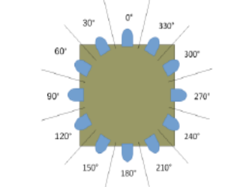

If a measured AOA falls in one such region, the resistor ratios and DC sources are reconfigured for one set of values covering the entire region. Therefore 12 sets of resistor ratios and DC sources will be needed, with digital control bits for selecting a specific set. This quantization of the AOA values to 30 degree intervals will introduce localization errors, but they may be negligible depending on the application. Similarly, for 3D, the spherical space around the target can be quantized to N hexagonal surfaces (hexagons) , each one covering a range of AOA values. Each hexagon can quantize a range of AOA values(azimuth,elevation) to one (x,y,z) coordinate. The circuit will therefore have N sets of resistor ratios and DC source values, one set for each hexagon. An implementation of a spherical optical sensor ( Free Space Optical, FSO ) antenna is described in Bilgi 2010 ; the figure below shows target node #3 , with hexagonal photo sensors on the sphere’s surface ( the target is inside the #3 sphere, #1 and #2 are anchors) :
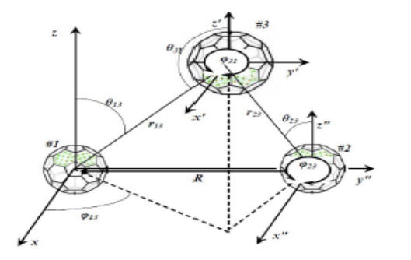
The second circuit, Differential equation solver ( OTA based) has been proven to always converge to stable 2D x,y values for positive-definite matrix A, based on the AOA-derived equations. Convergence in the 3D case has not been proven. It can also be applied to a 2D quantized 360 degree space, with 12 30-degree regions. Each set can be implemented with specific OTA GM , DC sources, and op-amp gain (resistor ratios ). Digital control bits can select a specific set for a measured AOA value falling in one of the 12 regions. Future work will identify the required scaling factor(s) so that the AOA-derived equation coefficients can map to implementable circuit parameters in PDK 45 nm.

References

[1] D. Frantal, D. Arbula “Mobile node localization using infrared angle of arrival sensor ” IEEE MIPRO 2015.

[2] V. Bonato, et al. “A Floating-point Extended Kalman Filter Implementation for Autonomous Mobile Robots” IEEE
Journal of VLSI Signal Processing 2007.

[3] S. Hajializad, “Nonparametric Density Function Estimation using Operational Transconductance Amplifiers”, M.S. Thesis, RNG project, UIC 2017

[4] R.J.Baker, “CMOS Circuit Design , Layout, and Simulation”, 3rd edition,

[5] M. Bilgi, M. Yuksel, and N. Pala, “3-D Optical wireless localization,” in Proc. IEEE GLOBECOM, Dec. 2010, pp. 1062–1066.

